WHAT IS AN ACID OR A BASE?
By the 1884 definition of Svante Arrhenius (Sweden), an acid is a material that can release a proton or hydrogen ion (H ⁺). Hydrogen chloride (HCl) in water solution ionizes and becomes hydrogen ions (H⁺) and chloride ions (Cl⁻). If that is the case, a base, or alkali, is a material that can donate a hydroxide ion (OH⁻). Sodium hydroxide (NaOH) in water solution becomes sodium ions (Na⁺) and hydroxide ions (OH⁻) . By the definition of both Thomas Lowry (England) and J.N. Brønsted (Denmark) working independently in 1923, an acid is a material that donates a proton and a base is a material that can accept a proton. Was Arrhenius erroneous? No.

The Arrhenius definition serves well for a limited use. We are going to use the Arrhenius definitions most of the time. The Lowry-Brønsted definition is broader, including some ideas that might not initially seem to be acid and base types of interaction. Every ion dissociation that involves a hydrogen or hydroxide ion could be considered an acid-base reaction. Just as with the Arrhenius definition, all the familiar materials we call acids are also acids in the Lowry-Brønsted model.

We can consider the same idea in the Lowry-Brønsted fashion. Each ionizable pair has a proton donor and a proton acceptor. Acids are paired with bases. One can accept a proton and the other can donate a proton. Each acid has a proton available (an ionizable hydrogen) and another part, called the conjugate base. (That word, 'conjugate' just means that it "goes with" the other part.) When the acid ionizes, the hydrogen ion is the acid and the rest of the original acid is the conjugate base. Nitric acid, HNO₃, dissociates (splits) into a hydrogen ion (H⁺) and a nitrate ion (NO₃⁻). The hydrogen almost immediately joins to a water molecule to make a hydronium ion (H₃O⁺). The nitrate ion is the conjugate base of the hydrogen ion. In the second part of the reaction, water is a base (because it can accept a proton) and the hydronium ion is its conjugate acid.
HNO₃ | + | H₂O |  | (NO₃)⁻ | + | (H₃O)⁺
ACID |  | BASE |  | CONJUGATE  BASE |  | CONJUGATE  ACID
In a way, there is no such thing as a hydrogen ion or proton without anything else. They just don't exist naked like that in water solution. Remember that water is a very polar molecule. There is a strong partial negative charge on the side of the oxygen atom and a strong partial positive charge on the hydrogen side. Any loose hydrogen ions, having a positive charge, would quickly find itself near the oxygen of a water molecule. At close range from the charge attraction, the hydrogen ion would find a pair (its choice of two pairs) of unshared electrons around the oxygen that would be capable of filling the its outer shell. Each hydrogen ion unites with a water molecule to produce a hydronium ion, (H₃O)⁺, the real species that acts as acid. The hydroxide ion in solution does not combine with a water molecule in any similar fashion. As we write reactions of acids and bases, it is usually most convenient to ignore the hydronium ion in favor of writing just a hydrogen ion, (H⁺).

PROPERTIES OF ACIDS
For the properties of acids and bases we will use the Arrhenius definitions.
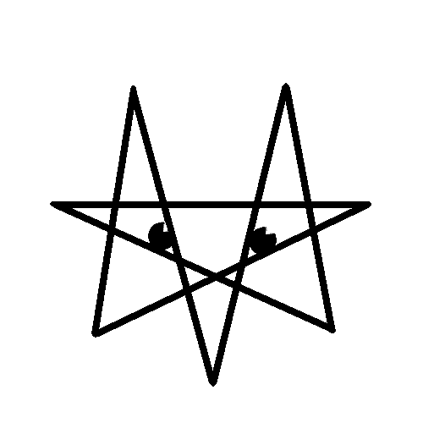Acids release a hydrogen ion (H⁺) into water (aqueous) solution. You will usually see the formula for an acid with the ionizable hydrogen at the beginning, such as HCl, hydrochloric acid, or acetic acid.
Acids neutralize bases in a neutralization reaction. An acid and a base combine to make a salt and water. A salt is any ionic compound that could be made with the anion of an acid and the cation of a base. The hydrogen ion of the acid and the hydroxide ion of the base unite to form water.
Acids corrode active metals. Even gold, the least active metal, is attacked by an acid, a mixture of acids called 'aqua regia,' or 'royal liquid.' When an acid reacts with a metal, it produces a compound with the cation of the metal and the anion of the acid and hydrogen gas. 2 Mg + 2 HCl 2 MgCl + H₂
Acids turn blue litmus to red. Litmus is one of a large number of organic compounds that change colors when a solution changes acidity at a particular point. Litmus is the oldest known pH indicator. It is red in acid and blue in base. The phrase, 'litmus test,' indicates that litmus has been around a long time in the English language. Litmus does not change color exactly at the neutral point between acid and base, but very close to it. Litmus is often impregnated onto paper to make 'litmus paper.'
Acids taste sour. TASTING LAB ACIDS IS NOT PERMITTED BY ANY SCHOOL. The word 'sauer' in German means acid and is pronounced almost exactly the same way as 'sour' in English. (Sauerkraut is sour cabbage, cabbage preserved in its own fermented lactic acid. Stomach acid is hydrochloric acid. Although tasting stomach acid is not pleasant, it has the sour taste of acid. Acetic acid is the acid ingredient in vinegar. Citrus fruits such as lemons, grapefruit, oranges, and limes have citric acid in the juice. Sour milk, sour cream, yogurt, and cottage cheese have lactic acid from the fermentation of the sugar lactose.

PROPERTIES OF BASES
Bases release a hydroxide ion (OH⁻) into water solution. (Or, in the Lowry-Brønsted model, cause a hydroxide ion to be released into water solution by accepting a hydrogen ion in water.)
Bases neutralize acids in a neutralization reaction. The word - reaction is: Acid plus base makes water plus a salt. Where 'Y' is the anion of acid 'HY,' and 'X' is the cation of base 'XOH,' and 'XY' is the salt in the product, the reaction is: HY + XOH HOH + XY
Bases denature protein. This accounts for the "slippery" feeling on hands when exposed to base. Strong bases that dissolve in water well, such as sodium or potassium lye are very dangerous because a great amount of the structural material of human beings is made of protein. Serious damage to flesh can be avoided by careful use of strong bases.
Bases turn red litmus to blue. This is not to say that litmus is the only acid - base indicator, but that it is likely the oldest one.
Bases taste bitter. There are very few food materials that are alkaline, but those that are taste bitter. It is even more important that care be taken in tasting bases. Again, NO SCHOOL PERMITS TASTING OF LAB CHEMICALS. Tasting of bases is more dangerous than tasting acids due to the property of stronger bases to denature protein. Some bases that are foods are vegetables, herbs, potatoes, and soy.

