Periodic Table Review
Essential Vocabulary:

Atom
Element
Atomic number
Atomic Mass
Proton
Neutron
Electron
Period
Group
Valence Electron
Properties

Reading the elements: Label with atomic number, atomic mass, symbol, name

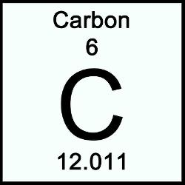

Number of protons:
(Same as atomic number)
Number of neutrons:
(Rounded atomic mass – atomic number)
Number of electrons:
(Same as atomic number)

Periods and Groups: label the Periods and Groups

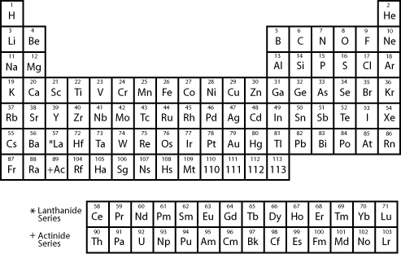

Alkali Metals:
- Alkali Metals are located in ________________ at the far left side of the periodic table. Note that ______________________ is not an alkali metal. All of the Alkali metals have ____________________________ in their outer shell. This is what gives them similar ____________________________. Alkali metals are __________________________________ and are not found in their _____________________ in nature. They are also all _______________ at room temperature. There are 6 Alkali Metals with symbols of ______, ______, ______, ______, ______, and ______
Alkaline Earth Metals:
- The Alkaline Earth Metals are located in ____________________, just to the right of the Alkali Metals. All of the Alkaline Earth Metals have ____________________________ in their outer shells. Alkaline Earth Metals are still __________________ but not as reactive as the ____________________________. These are sometimes found in their pure form in nature as ___________________. There are 6 Alkaline Earth Metals with symbols of ______, _______, _______, ______, ______, and _______

Transition Metals
- The Transition Metals are located in the ________________ of the Periodic Table from _________________ _______________________. The number of ______________________________ for the Transition Metals _______________, but stays the same for each _________________. Transition Metals are all _______________ at room temperature except for _____________________. They are good _______________________ of heat and electricity, ___________________, shiny, and are ________ very reactive. They still ____________ with other elements but _________________ as the Halogens, Alkali Metals, or Alkaline Earth Metals. These metals are what we __________________________ as metals in our daily lives. There are many Transition Metals but some examples are __________________, ___________________, ____________________, ________________________
Halogens
- The Halogens are located in _____________________ in the 2nd to the last column on the right. All of the Halogens have ______________________ so they just need 1 electron to fill their outer shell. Halogens are ________________________________ and usually react with the _______________________. This is because the Alkali Metals need to ________ 1 electron and the Halogens need to ________ 1 electron. The halogens are all _________________ and are usually gases at room temperature. There are 5 Halogens with the element symbols ______, ______, ______, ______, and ______
Noble Gases
- The Noble Gases are located all the way to the right of the table in __________________. The Noble Gases are ________________ because they are _____________________. The Noble Gases have _____________ ______________________ in their outer shell and don’t need to _______________ any electrons. The Noble Gases are all _________________________ and are commonly found in their __________________ in the atmosphere. There are 6 Noble Gases with symbols ______, ______, ______, ______, ______, and ______.

Metals, Nonmetals, and Metalloids – General properties
Metals | Nonmetals | Metalloids

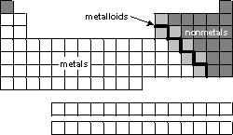

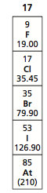
Sample TCAP Questions

- What is the atomic number of Fluorine (image on right)?

- Which statement best describes the reactivity of the shaded elements nitrogen (N), oxygen (O), and fluorine (F)?
- Which element from period 2 has the lowest atomic mass (use your periodic table from the notes)

  - Li
  - Be
  - Ca
  - Ne

- Based on their locations on the Periodic table, which two elements share the most similar chemical properties?

  - K and Kr
  - Be and Ba
  - S and Sn
  - H and I

- Based on its position on the periodic table, which element is the heaviest

  - Helium (He)
  - Neon (Ne)
  - Argon (Ar)
  - Krypton (Kr)

- A property that the elements Fe, Co, and Ni have in common is that they are all

  - Chemically inert
  - Halogens
  - Transition Metals
  - Poor Electrical Conductors

