Atoms and States of Matter/Elements, Compounds, and Mixtures Study Guide
Atoms:
Everything in the universe is made up of tiny particles called _____________.
Atoms cannot be _______________ into smaller pieces.
Diagram of an atom:
Subatomic particle | Location | Charge | Mass
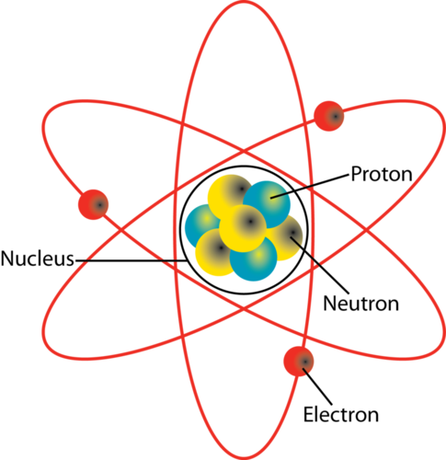

States of Matter
State of Matter | Energy | Particle movement | Particle arrangement

Changes of state:
Solidification: ________________________________________________________________________________________________
Melting: _______________________________________________________________________________________________________
Condensation: ________________________________________________________________________________________________
Vaporization: _________________________________________________________________________________________________
Sublimation: __________________________________________________________________________________________________
Depositions: __________________________________________________________________________________________________

Density:
The equation for density is _________________________________________________________________________________.
Density is a ___________________________________ between the amount of _______________ an object has and the amount of _______________________ (volume) that same object takes up. Metals such as iron, gold, and lead have ____________________ densities and will feel ___________________. Gases such as oxygen, and nitrogen, which have a mass, have ________________________ densities and are very _____________________.
What units can we use to measure mass? _________________________________________________________________
What units can we use to measure volume? ______________________________________________________________

Elements and Compounds:
Elements are always composed of the same type of _________________________. All of the elements on the periodic table are ______________________________ of elements. _____________________________ form when 2 or more ____________________________ elements form ______________________________ bonds. Compounds of the same elements have very different ____________________________ of the individual elements. For example, ______________________ (Na) is a highly reactive Alkali Metal and ___________________________ (Cl) is a highly reactive Halogen. Sodium and chlorine chemically combine to form NaCl (sodium chloride) more commonly known as _________________.
- Elements have symbols of 1 or 2 letters and there will only be 1 ___________________ letter.
- Compounds will have ___________________________ 2 capital letters, sometimes many more.
Compounds and Mixtures:
Compounds and mixtures are different because of ______________________________________________________. Compounds can only be separated by breaking the _______________________________________ between the elements. Breaking the chemical bonds will _______________________ new substances. Mixtures can be separated by physical means. Some examples of physical separations are __________________________, distillation, breaking, using a magnet, _______________________________, density, ______________________, and others. When mixtures are separated, no new substances are _____________________________.

Homogeneous vs. Heterogeneous mixtures
A ___________________________________ mixture is when a mixture is _________________________ throughout. Each substance is ___________________________ throughout the whole mixture. A _________________________ mixture is not uniform throughout and the _____________________________________________________. Some examples of _________________________________ mixtures are sand, and saltwater. Some examples of ______________________________ mixtures are oil and water, sand and water,

Chemical makeup of the atmosphere:
Nitrogen 78%, Oxygen 21%, Argon 0.9%, Carbon Dioxide 0.3%, trace amounts of other gases

Sample TCAP Questions
- What is the smallest unit of matter that cannot be broken down into smaller substances?

  - Protons

  - Neutrons

  - Electrons

  - Atoms

- Which statement is true about the clouds, a chair, and a lake

  - They are all living things
  - They are all liquids

  - They are all made up of atoms
  - They are made of the same elements

- Particles in a substance are widely separated and move independently from place to place. The substance could be a

  - Solid only.
  - Gas only.
  - Gas or solid only.
  - Gas, liquid, or solid.

- Which diagram best shows the type of particle arrangement of a gas?

  - 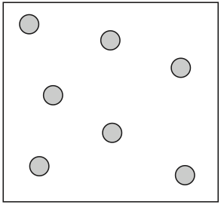
  - 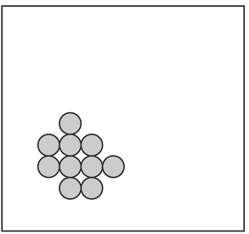
  - 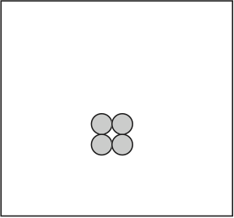
  - 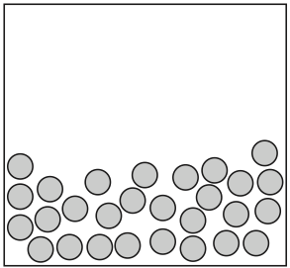
- Diagrams of molecular arrangements are shown below. A solid is best shown in diagram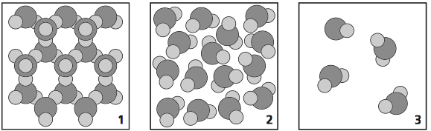

  - 3
  - 3 and 1
  - 1
  - 2 and 3

- Each particle in a sample of matter vibrates but does not move from its location. In what state of matter is the sample?

  - Liquid
  - Solid
  - Gas
  - Plasma

- When liquid water freezes to form ice the molecules are

  - Losing energy
  - Gaining energy
  - Energy is staying the same
  - Unable to tell

- Given the following chart, what is the order of elements from the most dense to the least dense
Element | Density
Aluminum | 2.7 g/cm³
Iron | 7.9 g/cm³
Gold | 19.3 g/cm³
Mercury | 13.5 g/cm³

  - Aliminum, Gold, Mercury, Iron
  - Gold, Iron, Mercury, Aluminum
  - Iron, Gold, Aluminum, Mercury
  - Gold, Mercury, Iron, Aluminum

- Given the formula D=M/V, what is the density of a rock measuring 64 grams and 16 cm³

  - 0.25 g/cm³
  - 4 g/cm³
  - 8 g/cm³
  - 1 g/cm³

- Which of the following is a compound

  - He
  - N₂
  - HCl
  - O

- Which of the following is an element

  - NaCl
  - H₂O
  - O₂
  - CO₂

- Tess has an unknown substance and after a chemical reaction she has 2 new substances with different properties. She can conclude that the original substance was an

  - Element
  - Compound
  - Mixture
  - Oxygen

- Jayden separates substances by sorting them into groups. After separating them, each group has different properties. Jayden can conclude that the original substance was an

  - Element
  - Compound
  - Mixture
  - Carbon Dioxide

- Which of the following is a heterogeneous mixture

  - A layered cake
  - Oil and water
  - A cup of tea
  - Salt

- The process of a solid turning into a gas is called

  - Condensation
  - Vaporization
  - Solidification
  - Sublimation
- When Cole separates iron from salt why is it considered a physical separation
  - Because he broke the chemical bonds between salt and iron
  - Because he used physical means and did not change either substance
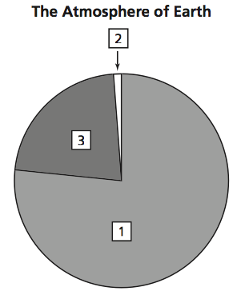
  - Because there was a chemical reaction
  - Because it took energy to remove the iron
- Which gas is represented by the number 1 in the graph?
  - Argon
  - Hydrogen
  - Nitrogen
  - Oxygen

