What are Physical Properties and Changes?
Physical Properties:
Physical properties can be observed or measured without changing the composition of matter. Physical properties are used to observe and describe matter.
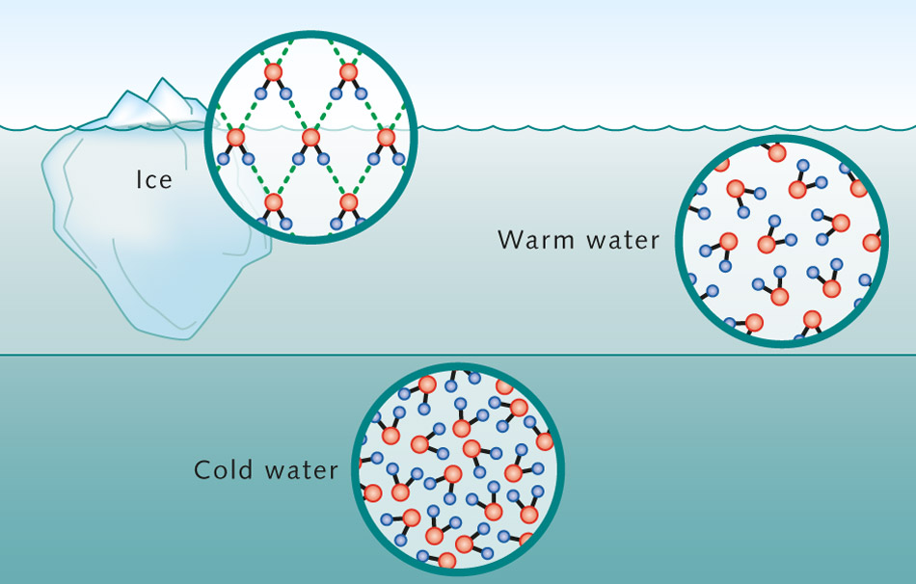
Physical properties include: appearance, texture, color, odor, melting point, boiling point, density, solubility, polarity, and many others. Properties that can be described using the body’s 5 senses are physical properties. The three states of matter are: solid, liquid, and gas. The melting point and boiling point are related to changes of the state of matter. All matter may exist in any of three physical states of matter. In the graphic on the left the solid and liquid forms of water - ice are shown. Notice how the molecules are still exactly the same composition, shape, and size. The only thing that is different is the arrangement.

Physical Changes:
A physical change takes place without any changes in molecular composition. The same element or compound is present before and after the change. The same molecule is present through out the changes. Physical changes are related to physical properties since some measurements require that changes be made.
Melting Point: As solid matter is heated it eventually melts or changes into a liquid state at the melting point. Ice (a solid form of water) melts at 0°C and changes to the liquid state. Carbon dioxide melts at -56.6°C
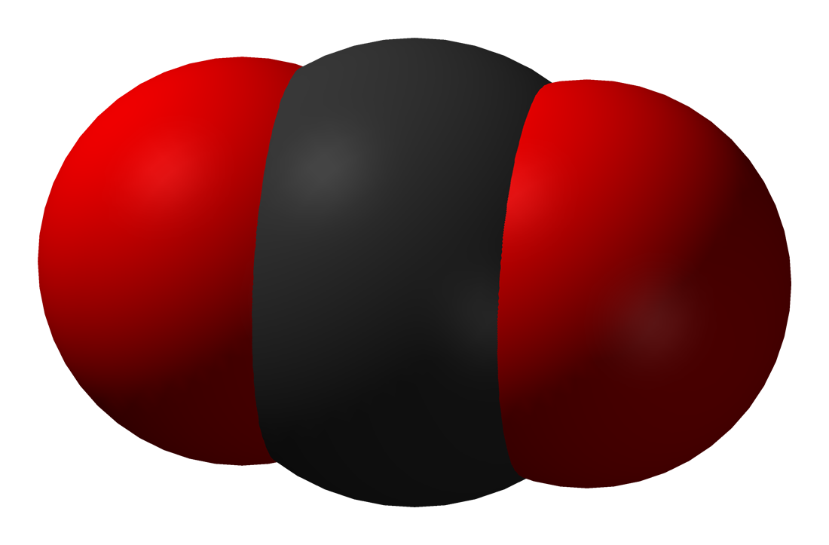
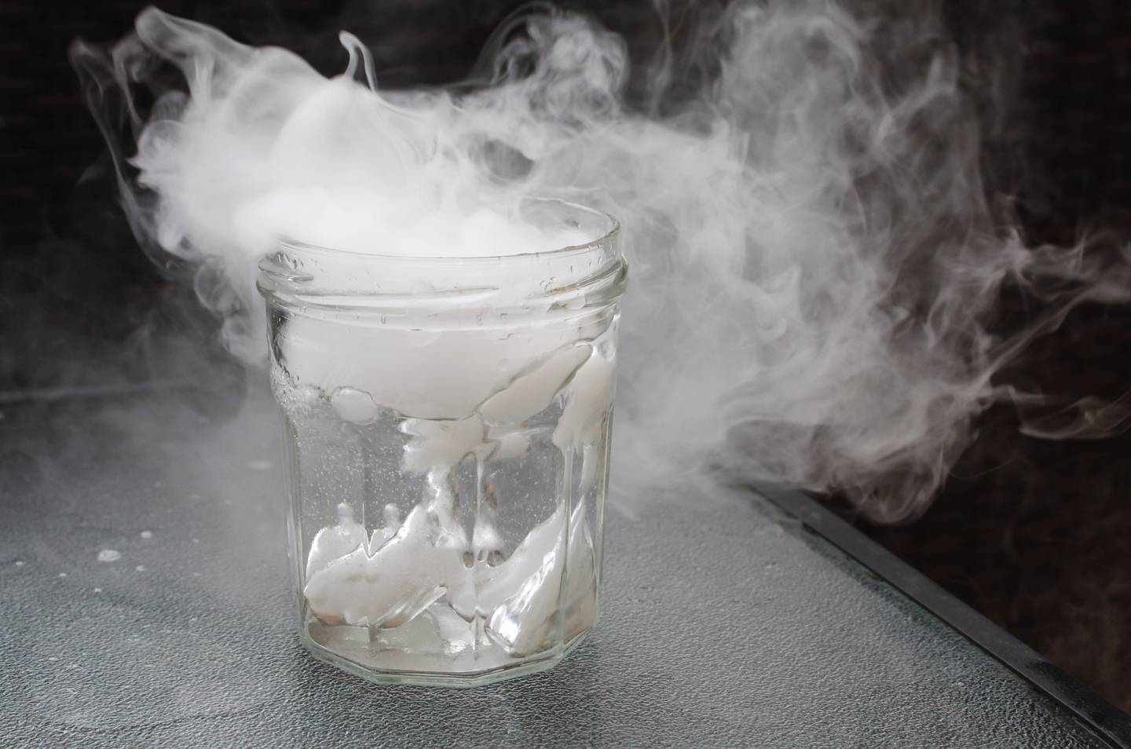
Boiling Point: As the liquid matter is heated further it eventually boils or vaporizes into a gas at the boiling point. Liquid water boils and changes into a gas, usually called steam or water vapor at 100°C. In all three states the same molecules of water (H₂O) are present. Carbon dioxide boils at -78.5°C. In the graphic on the left a block of dry ice as a solid is changing to the gaseous state. The molecules of CO₂ are still exactly the same in both the solid and gaseous states.

What are Chemical Properties and Changes?

Chemical Properties:
Chemical properties of matter describe its "potential" to undergo some chemical change or reaction by virtue of its composition. What elements, electrons, and bonding are present to give the potential for chemical change. It is quite difficult to define a chemical property without using the word "change". Eventually you should be able to look at the formula of a compound and state some chemical property. At this time this is very difficult to do and you are not expected to be able to do it. For example hydrogen has the potential to ignite and explode given the right conditions. This is a chemical property. Metals in general have they chemical property of reacting with an acid. Zinc reacts with hydrochloric acid to produce hydrogen gas. This is a chemical property.

Chemical Changes or Reactions:
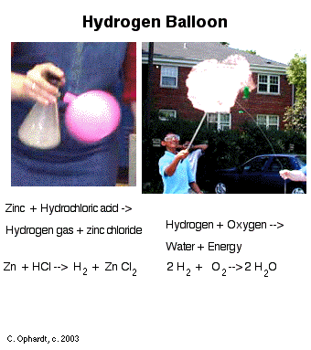
Chemical change results in one or more substances of entirely different composition from the original substances. The elements and/or compounds at the start of the reaction are rearranged into new product compounds or elements. In order for something to be classified as a chemical change, a new substance must be formed. A chemical change alters the composition of the original matter. Different elements or compounds are present at the end of the chemical change. The atoms in compounds are rearranged to make new and different compounds. In the example to the right, hydrogen and oxygen are combined in a balloon and a spark pops the balloon causing an explosion (chemical reaction). The oxygen and hydrogen gas combine to form water. Water has different chemical and physical properties than oxygen and hydrogen and has a different chemical formula so it is a new substance, and evidence that a chemical reaction has occurred.

Questions: Answer each question on a sheet of lined paper in your notebook. Use complete sentences and proper grammar and punctuation.
- What is a physical property?
  - What is an example of a physical property?
- What is a physical change?
  - What is an example of a physical change?
- What is a chemical property?
  - What is an example of a chemical property?
- What is a chemical change?
  - What is an example of a chemical change?

Synthesize what you just learned. Answer the following question in a full paragraph.
Where do we see evidence of physical and chemical changes every day?

